**User Guide – Using a Graphical User Interface**

**Based on Monte Carlo Simulation via PyCharm**

PUBAFRS5620: Rapid Innovation for Public Impact

The Ohio State University, John Glenn College of Public Affairs

December 9, 2022

**Sponsored by:**

|  |  |  |
| --- | --- | --- |
|  |  |  |
| **MDA** | **NASA** | **NAVSEA** |

**Written by:**

|  |  |
| --- | --- |
| Kaite Hu | hu.2124@buckeyemail.osu.edu |

Table of Contents

1 – Installing Anaconda and PyCharm on Windows Tutorial 1

1.1 Download and Install Anaconda 1

1.2 Download and Install PyCharm 6

2 – Configure a Conda Environment & Run the Code in PyCharm 10

2.1 Create a New Conda Environment from a PyCharm Project 10

2.2 Configure the Default Requirements File 13

2.3 Run the Code 15

3 – Graphical User Interface User Guide 16

3.1 INPUT Section: 16

3.1.1 Step 1 16

3.1.2 Step 2 18

3.1.3 Step 3 19

3.1.4 Step 4 19

3.1.5 Step 5 21

3.2 OUTPUT Section 23

3.2.1 Results for Each Run 24

3.2.2 Plots 27

3.2.3 Results Summary 30

4 – Monte Carlo Simulation Logic 31

4.1 Major Modeling Assumptions 31

4.2 Simulation Flowchart 32

4.3 Key Code Illustration 33

4.3.1 contours_detecting 33

4.3.2 whisker_generator 33

4.3.3 computeCode 34

4.3.4 cohenSutherland 34

4.3.5 check_Bridged 35

4.3.6 calculate_resistance 36

4.3.7 conductor_pair_DF 36

4.3.8 draw_img 36

4.3.9 export_Pairs_Data 37

5 - Codes for GUI and Monte Carlo Simulation 39

5.1 MCS_gui.py 39

5.2 Main_Monte_Carlo.py 47

# 1 – Installing Anaconda and PyCharm on Windows Tutorial

## 1.1 Download and Install Anaconda

Anaconda is a package manager, an environment manager, and Python distribution that contains a collection of many open-source packages.

Below are the detailed steps for downloading and installing Anaconda

1. Visit the website [Anaconda | Anaconda Distribution](https://www.anaconda.com/products/distribution#windows) and click on **Download**.



1. Once the download is completed, run the exe for install Anaconda. When the screen below appears, click on **Next**.

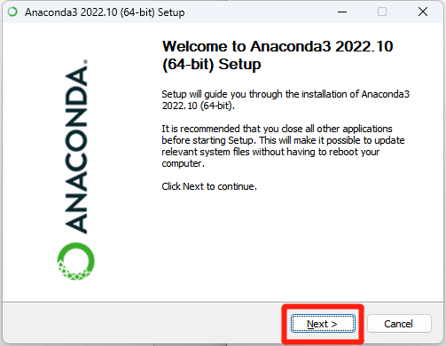

1. Read the license agreement and click on **I Agree**.

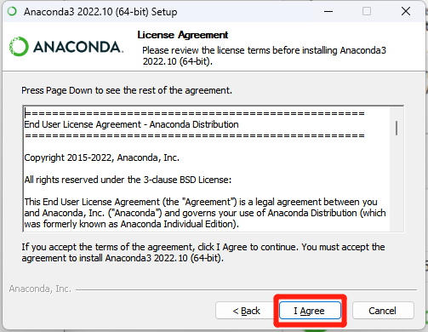

1. Click on **Next**

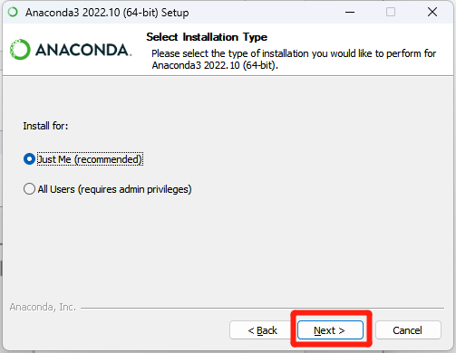

1. Select your installation location and then click on **Next**

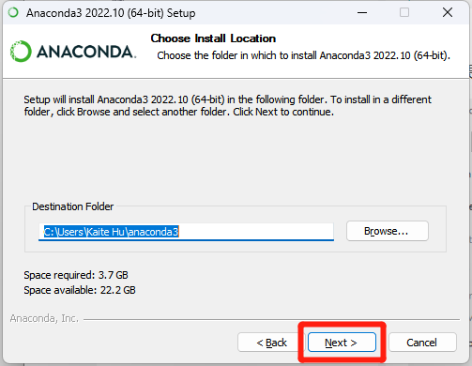

1. Check the second box to **Register Anaconda3 as your default Python 3.9**, and click on **Install**

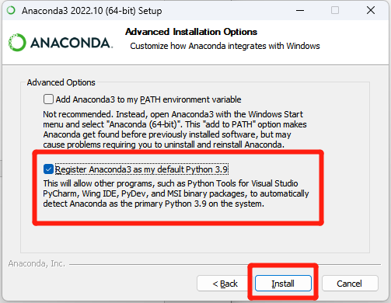

1. Click on **Next**

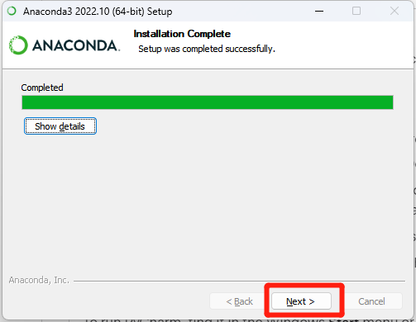

1. Click on **Next**

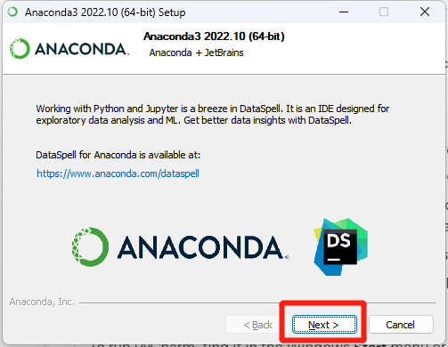

1. Click on **Finish**

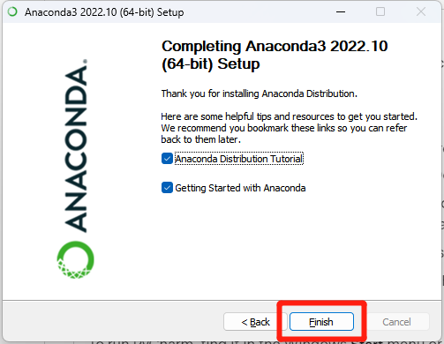

## 1.2 Download and Install PyCharm

PyCharm is a cross-platform editor developed by JetBrains. PyCharm provides all the tools you need for productive Python development.

Below are the detailed steps for downloading and installing PyCharm.

1. Visit the website [Download PyCharm: Python IDE for Professional Developers by JetBrains](https://www.jetbrains.com/pycharm/download/#section=windows) and click on the **Download** under the Community Section.

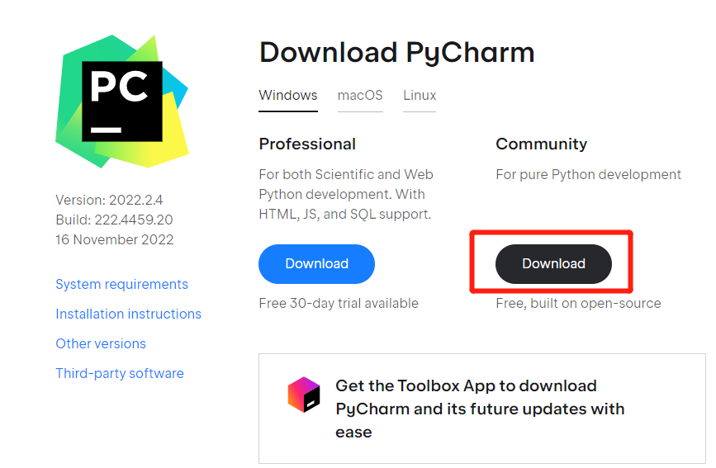

1. Once the download is completed, run the exe for install PyCharm. When the screen below appears, click on **Next**.

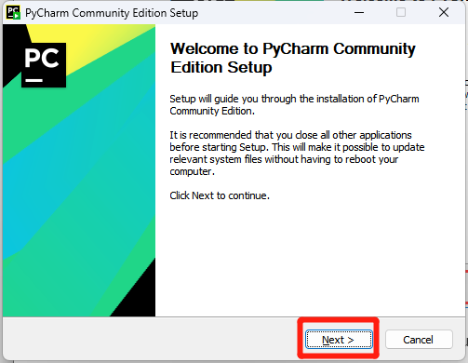

1. Change the installation path if required. Click on **Next**.

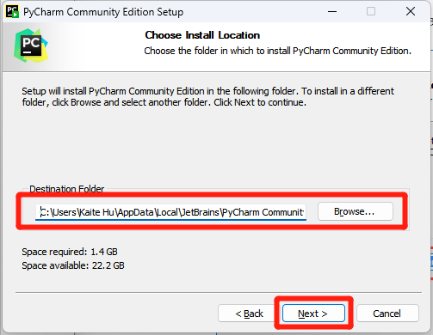

1. You can create a desktop shortcut if you want and click on **Next**.

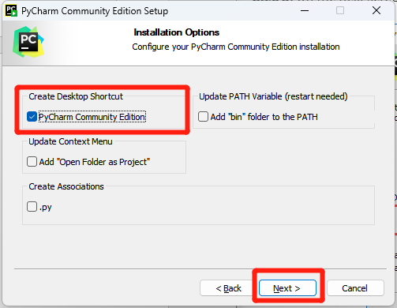

1. Keep selected JetBrains and click on **Install**

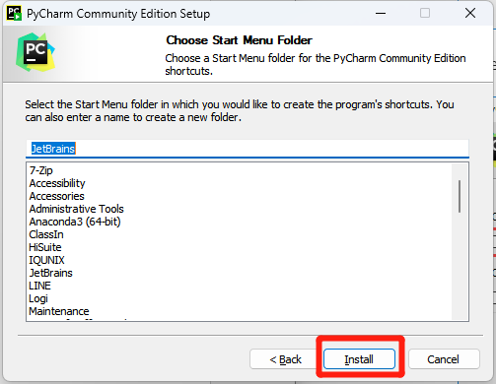

1. Once installation finished, check the “Run PyCharm Community Edition” box and click **Finish**.

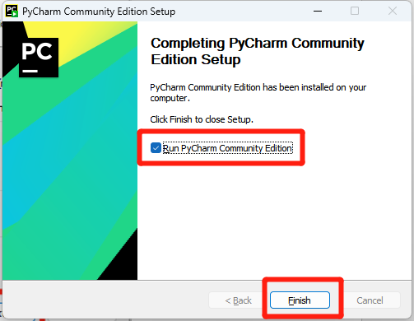

1. Read the PyCharm User Agreement, check the confirmation box and click on **Continue**.

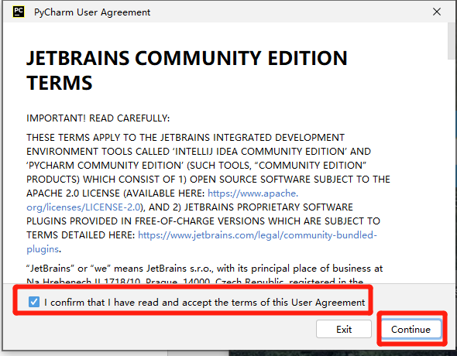

# 2 – Configure a Conda Environment & Run the Code in PyCharm

## 2.1 Create a New Conda Environment from a PyCharm Project

1. After opening PyCharm, click **New Project**

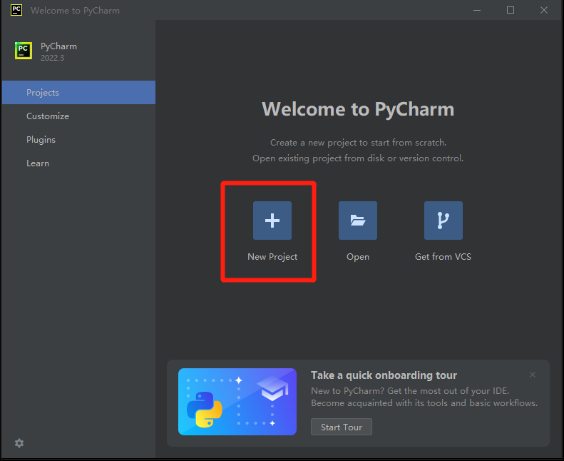

1. Create the new project and conda environment
   * 1. Use **Location** to change your project’s name and file location.
     2. Your **New environment** should use Conda instead of the default Virtualenv
     3. Specify the location and name of the new Conda environment in **Location**.
        + Here I created a **Tin_Whiskers_Project** folder within **envs** folder under the **anaconda3** where the Anaconda is installed
        + Note: the directory where the conda environment is located must be empty
     4. Select Python version 3.10
     5. Specify the location of the Conda executable file
        + Select the **conda.exe** within **Scripts** folder under the **anaconda3**
     6. Click on **Create**

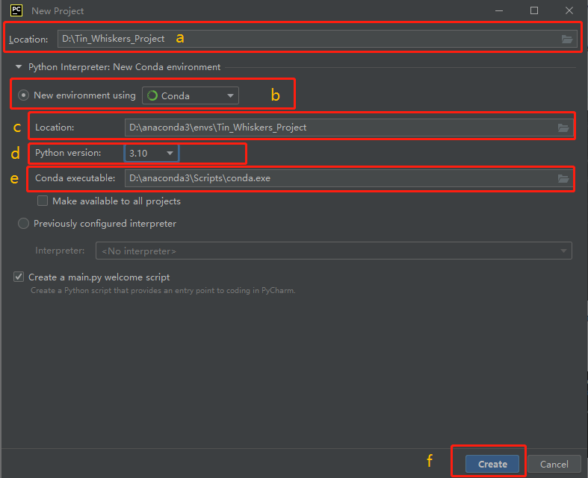

1. I saved all files that will be used for this project under the same directory where I create the project (D:\Tin_Whiskers_Project), so a window popped up asking if I want to create project from existing sources. Click on **Create from Existing Sources**.

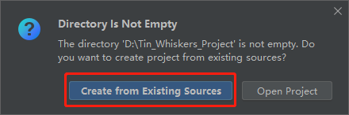

1. If you haven’t saved the code and other project files to the project folder, you can move them to the project folder after creating the project. Project files include:
   * 1. **Main_Monte_Carlo.py**
     2. **MCS_gui.py**
     3. **requirements.txt**
     4. **Test_Case**
        + Test case1.png
        + Test case2.png
     5. **arial.ttf**

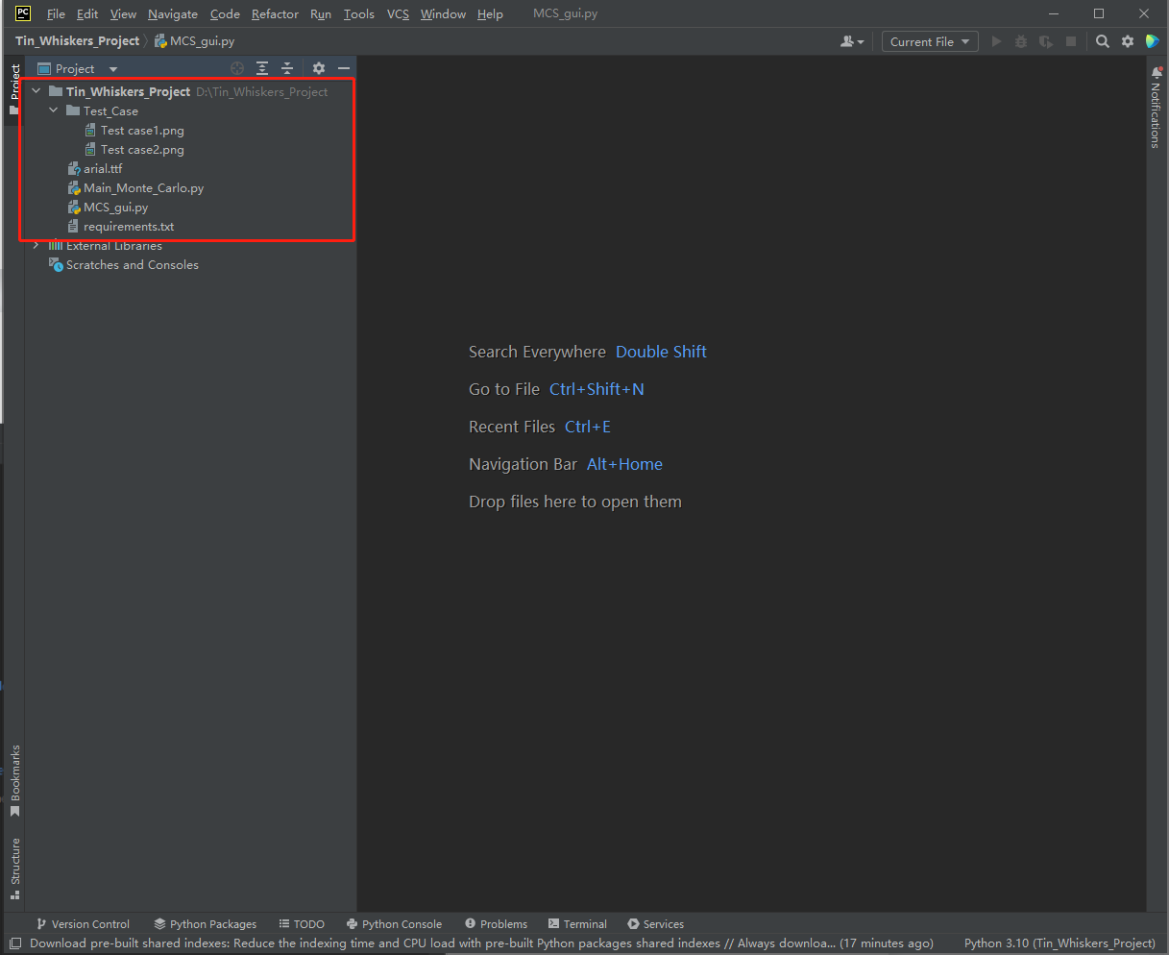

## 2.2 Configure the Default Requirements File

Save the “requirements.txt” file under the same folder of the project. This file will help you install all the packages needed for this project.

1. From the **File** menu, select **Settings**.

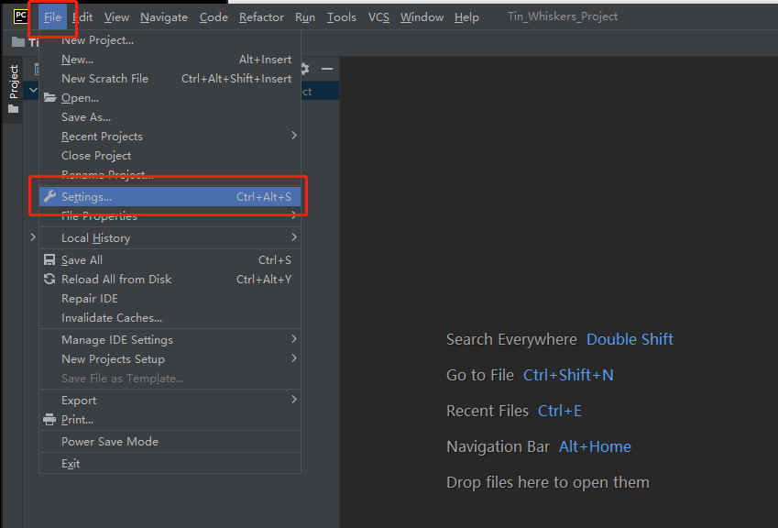

1. Select **1) Tools, 2) Python Integrated Tools,** and then **3) select the “requirements.txt” file**. Click **4) Apply** and then **5) OK**.

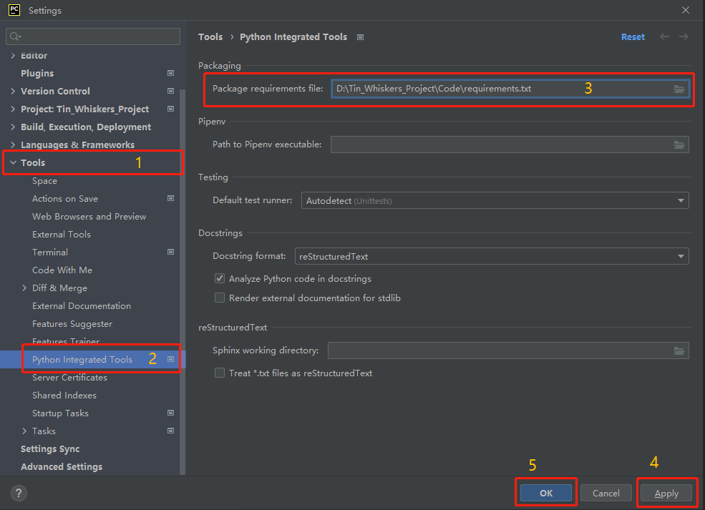

1. Open the “requirements.txt” file in PyCharm. You will get a notification to install the libraries on top of the file, click on **Install requirements** to install. (Note: all the files shown in the picture are NOT the final versions.)

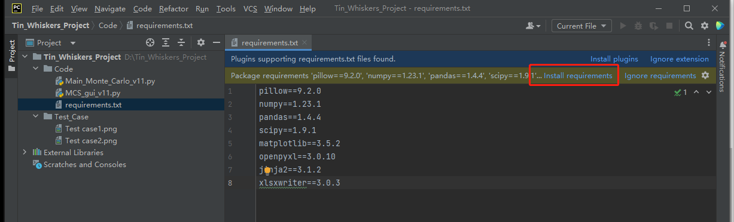

1. After installing all packages, you are ready to run the code.

## 2.3 Run the Code

1. Open “**MCS_gui.py**” in PyCharm

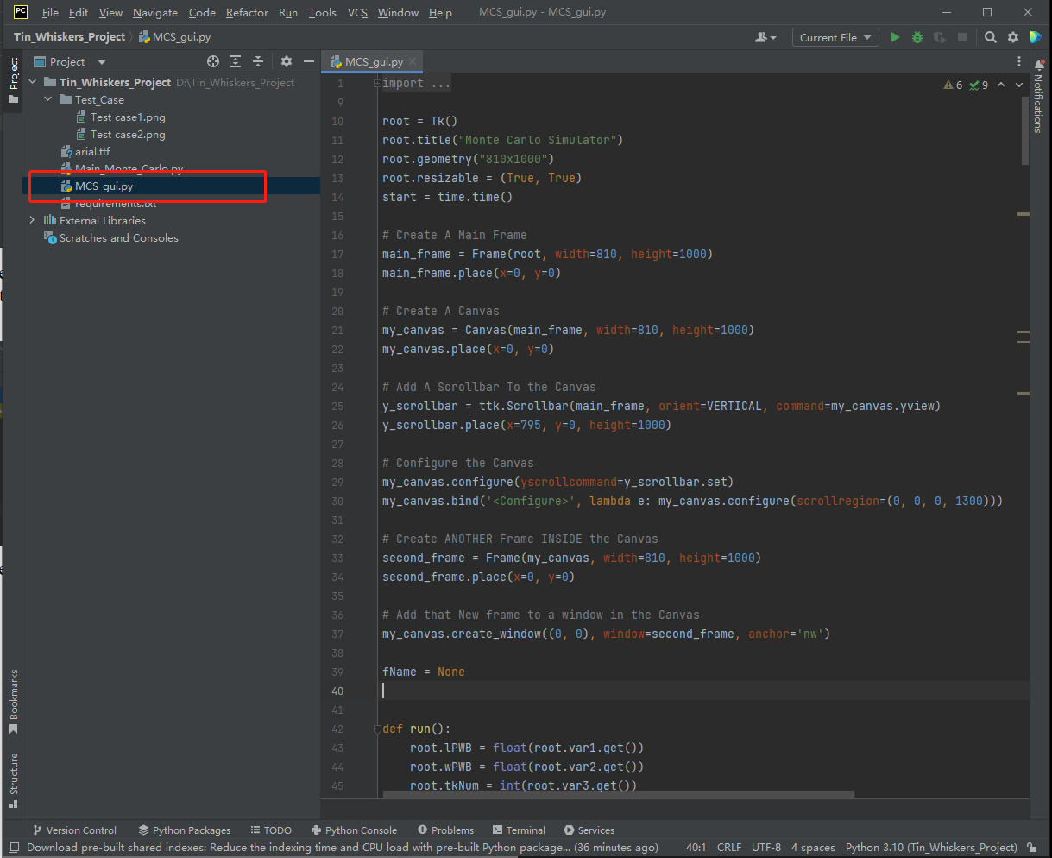

1. Right click on the **Editor** and click **Run MCS_gui**

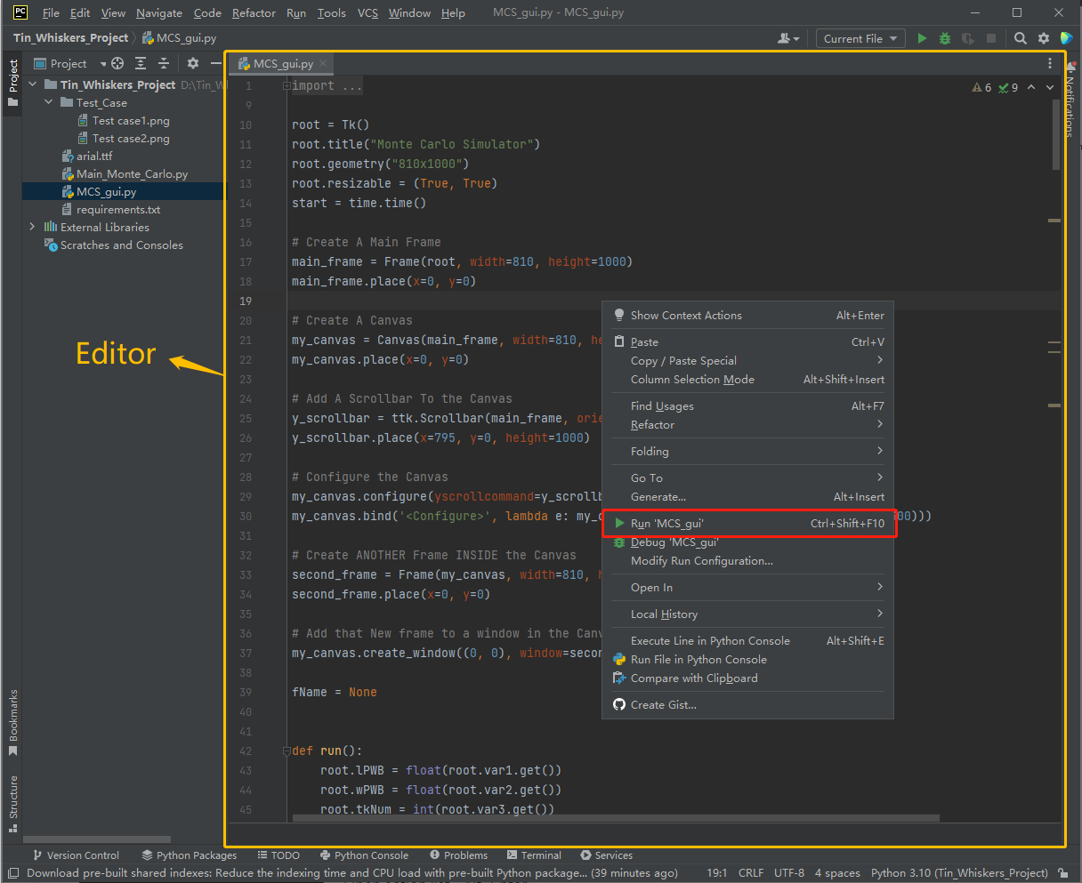

# 3 – Graphical User Interface User Guide

## 3.1 INPUT Section:

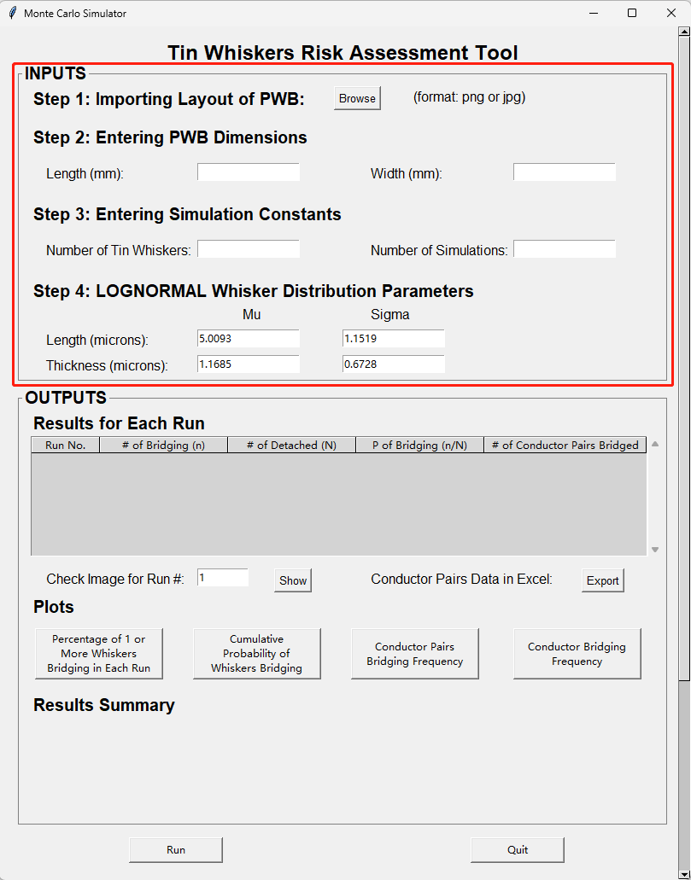

**Figure 1:** Initial State of the GUI

3.1.1 Step 1**:** Click on the **“Browse”** to import the layout of the circuit board. A text message “File Opened” will show up once you import your file.

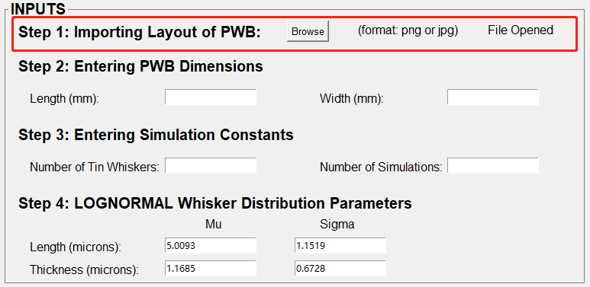

**Figure 2**: Step1: Importing Layout of PWB

Several criteria of the imported picture need to be met to enable the success of simulation:

1. The shape of the circuit board and all exposed conductors should be rectangular
   * If the conductors are not rectangular, even if the tool can be run without errors, you will get an **inaccurate** **result** of the probability of whisker bridging for all simulation trials. This is because the rectangular conductor coordinate will be detected and its top-left and bottom-right corner points will be represented by a list ([x_min, y_min, x_max, y_max]) in the code, which will be used for the rest of the algorithms. Other shapes of conductor will be represented by completely different lists, which cannot be processed by the current tool.
2. The color of the circuit board and the color of the conductors need to be two distinct colors (i.e., PWB: black, conductors: white)
3. The more pixels the picture has, the more accurate the simulation will be
4. Image format should be **jpg or png**

For the first version of the tool, a photograph of the PWB is used to generate the PWB and exposed conductor coordinates via image processing techniques. **Table1** gives examples for two test cases.

For the future version, the tool may allow the user to enter PWB and exposed conductor coordinates through other approaches such as direct data entry or via importing appropriate Gerber files, in which other shapes, in addition to rectangle, of exposed conductors are allowed.

Test cases example:

|  |  |
| --- | --- |
| **Table1: Image Conversion of Test Cases** | |
| **Test Case 1**: A small area in iPhone Circuit Card | **Test Case 2**: Standard Memory Card |
| Length: 10.08 mm | Length: 133 mm |
| Width: 5.73 mm | Width: 30 mm |
|  | HP - DDR4 - module - 16 GB - SO-DIMM 260-pin - 3200 MHz / PC4-25600 - unbuf |
| **Use tools such as PowerPoint or Photoshop to create the following images manually** | |
| **↓** | **↓** |
|  |  |
| **Image processing algorithm will detect the PWB and conductor coordinates in pixel unit** | |
| **↓** | **↓** |
|  |  |

3.1.2 Step 2**:** Entering the PWB dimensions, including the length and width, in the millimeters.

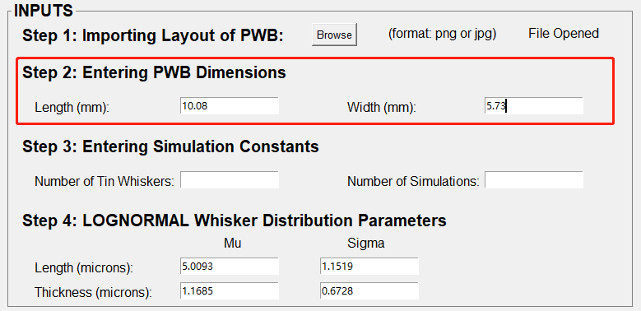

**Figure 3:** Entering PWB Dimensions

1. “PWB dimensions” here only means the dimensions of the area that you are going to analyze. If you are analyzing a small area in a circuit board, do not enter the dimension of the whole circuit board, it will return incorrect results.
2. These two entries only allow you to enter an integer or float number. (i.e., Enter “10.08” as length and “5.73” as width for test case 1)
3. Negative value is not allowed.

3.1.3 Step 3**:** Entering the simulation constants.

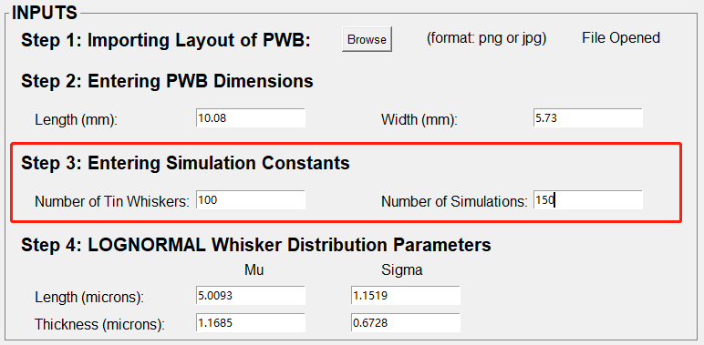

**Figure 4:** Entering Simulation Constants

1. The 1st entry: inputting the number of tin whiskers randomly falling on the circuit board in one simulation run.
2. The 2nd entry: inputting the number of simulations that you want the tool to run through.
3. These two entries only allow to enter an integer.

3.1.4 Step 4**:** Entering the Lognormal Whisker distribution parameters in microns.

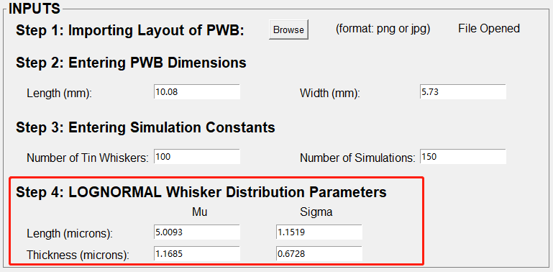

**Figure 5:** Entering LOGNORMAL Whisker Distribution Parameters

1. Default numbers were set based on the figure extracted from master’s thesis of L. Panashchenko, 2009.

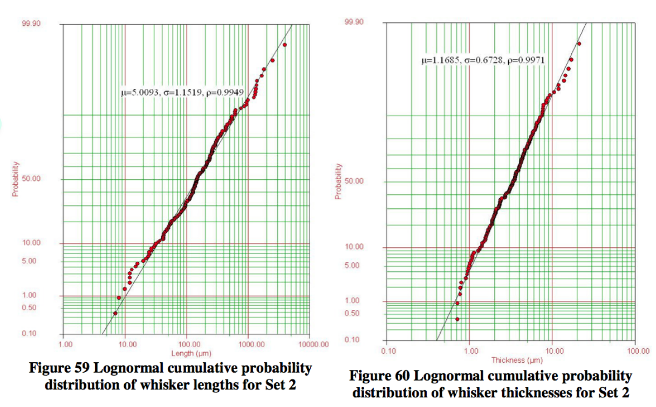

**Figure 6:** Lognormal cumulative probability distribution of whisker lengths and thicknesses

1. The numbers could be modified according to your requirements but should be positive integers or floating numbers in microns.

3.1.5 Step 5**:** Click on the **“Run” button** at the bottom left.

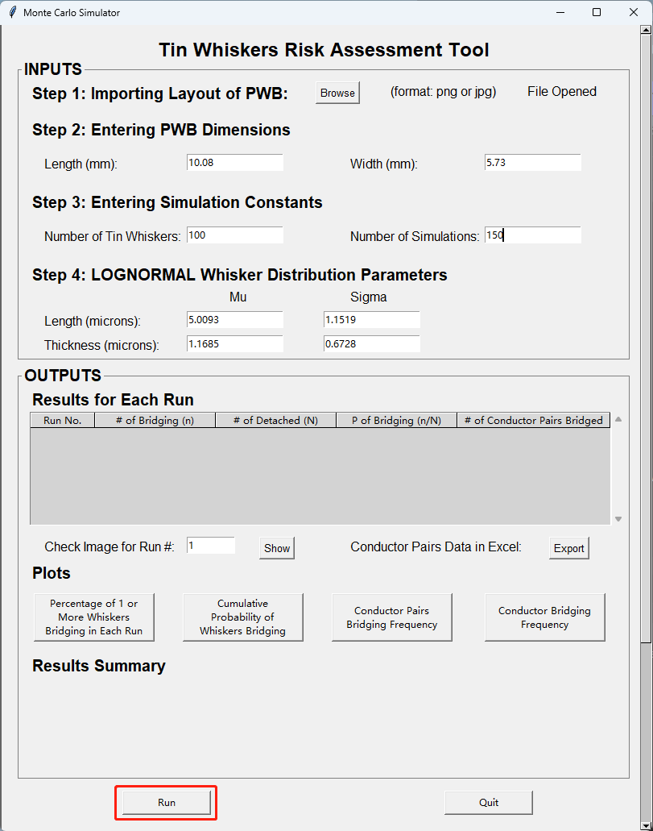

**Figure 7:** Run Button

1. A window will pop up showing the changing cumulative probability **per fifty whiskers**.
   * Since the y ticks are fixed, those probabilities that are greater than 0.045 won’t be included in this graph. Ideally, the y-axis should be scaled for those situations with higher probability of occurrence, but because this dynamic diagram is drawn before getting the final probability, from the point of view of writing code, making the y axis dynamic is a lot more complicated than making it fixed. This could be fixed in future work.
2. This dynamic diagram is only used to show the process of simulation. It will be automatically closed after the simulation is completed and will not be saved anywhere on the computer.

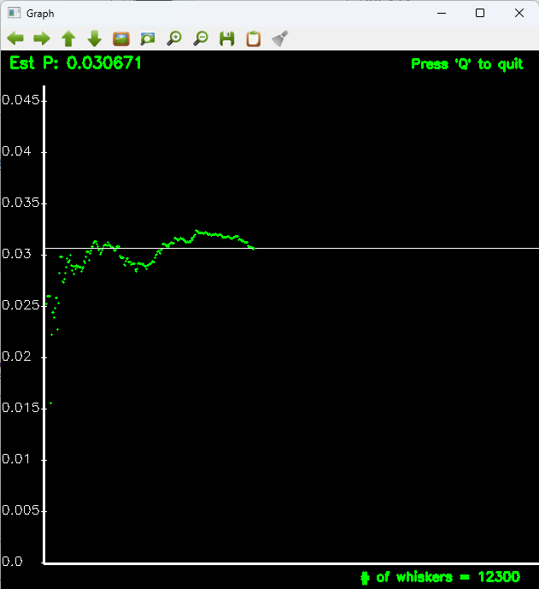

**Figure 8:** Number of Whiskers (50 whiskers are grouped at a point) **vs.** Cumulative Probability

1. After the simulation is completed, results will be displayed in the OUTPUT section.
2. Five images will be saved to the project’s directory. These images will be shown in the OUTPUT section. The file names are as follows (“# of simulations” in curly bracket is the value of number of simulations user inputs):
   * Circuit Board Layout with conductor numbers
   * Percentage of Whiskers Bridging after {# of simulations} simulations
   * Cumulative Probability after {# of simulations} simulations
   * Conductor Pairs Bridging Frequency after {# of simulations} simulations
   * Conductor Bridging Frequency after {# of simulations} simulations
3. If a new simulation also runs the same number of simulations as the last simulation, the original images under the same folder will be overwritten by the new images.
   * To save the images you want, you can move them to another folder
   * Potential future work: Name the file with a timestamp, or add allow user to provide a File Name which can become

3.2 OUTPUT Section**:**

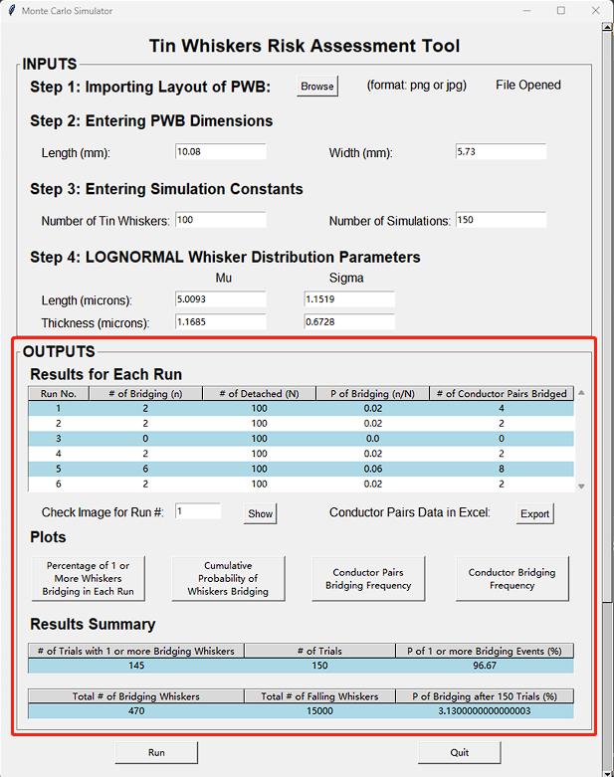

**Figure 9:** Final State of GUI

3.2.1 Results for Each Run**:** This part shows run number, number of bridging whiskers (n), number of detached whiskers (N), probability of bridging (n / N) and number of conductor pairs bridged by the “n” bridging whiskers.

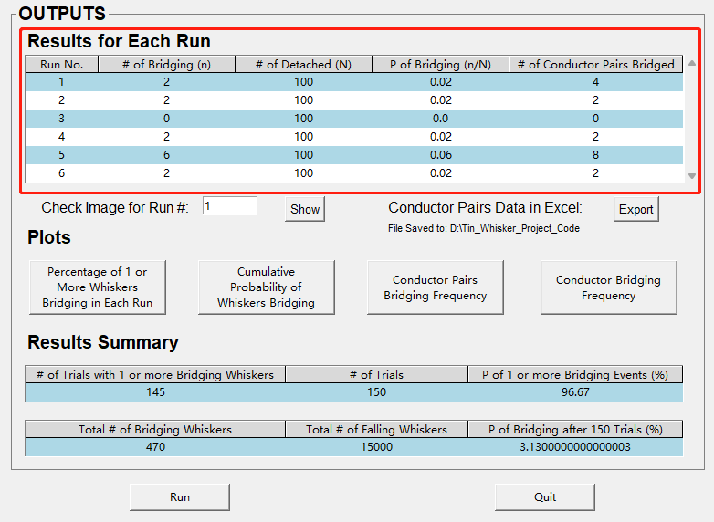

**Figure 10:** Results for Each Run

1. To view how the “N” whiskers were lying on the circuit board in a specific run, you can enter the run number, which should be an integer, to the entry after the text “Check Image for Run#:” and click the **“Show” button**.

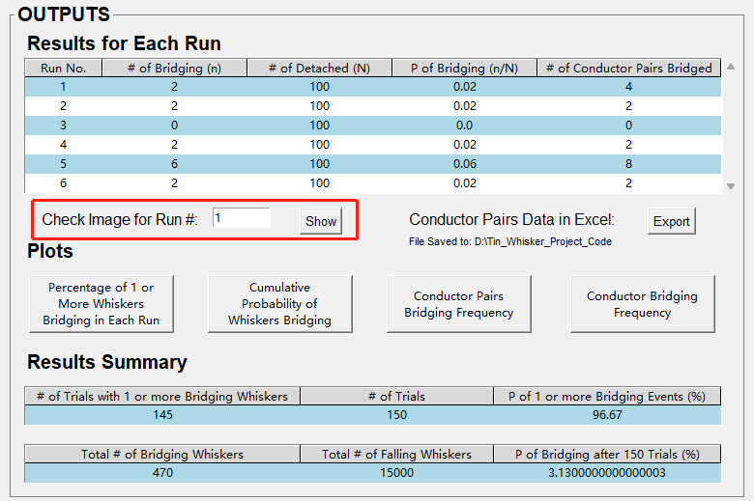

**Figure 11:** Check Image for Specific Run

* + The images opened won’t be saved to your computer since the algorithm behind this button is to run a function to draw the image. However, you can manually save the image you want since it is opened by your computer’s default photo viewer application.
  + This image will include the conditions of whiskers (red: bridging; green: not bridging), the conductor numbers (in orange) and a plotting scale (at right bottom in orange). An example is shown below:

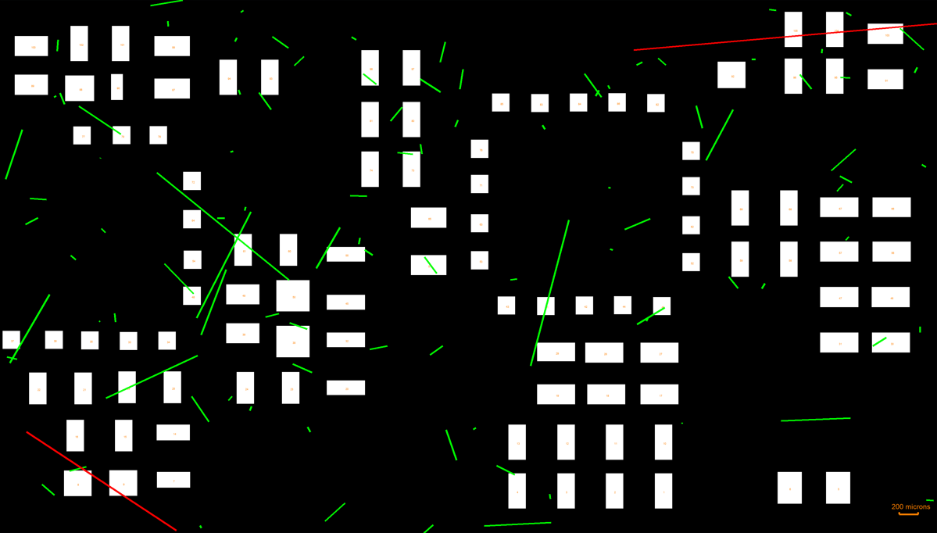

**Figure 12:** Image of Whisker Status for Run #1

1. To check the bridging conductors’ pairs and bridging frequency, click the **“Export” button**.

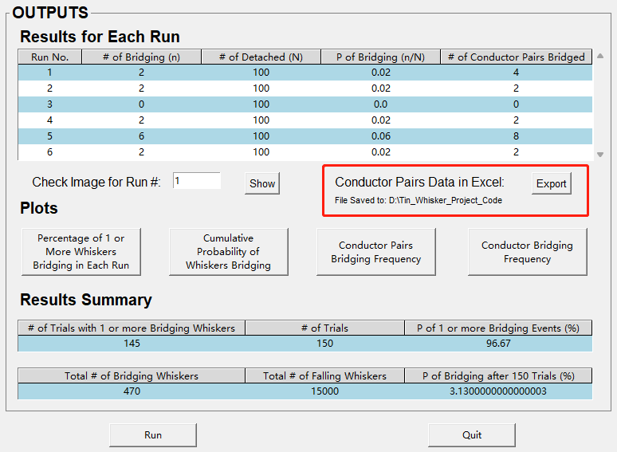

**Figure 13:** Export the Bridging Conductor Pairs Data to Excel

* + An Excel file will be saved to the project’s directory.
  + File name will be in this format: “Output after {# of runs} runs ({# of whiskers} in each run)”.
  + Conductor pairs and conductors bridging data will be exported to three sheets
    - Sheet #1: Run number, whisker number, bridging conductor pairs, and an image showing conductors’ number in circuit board.

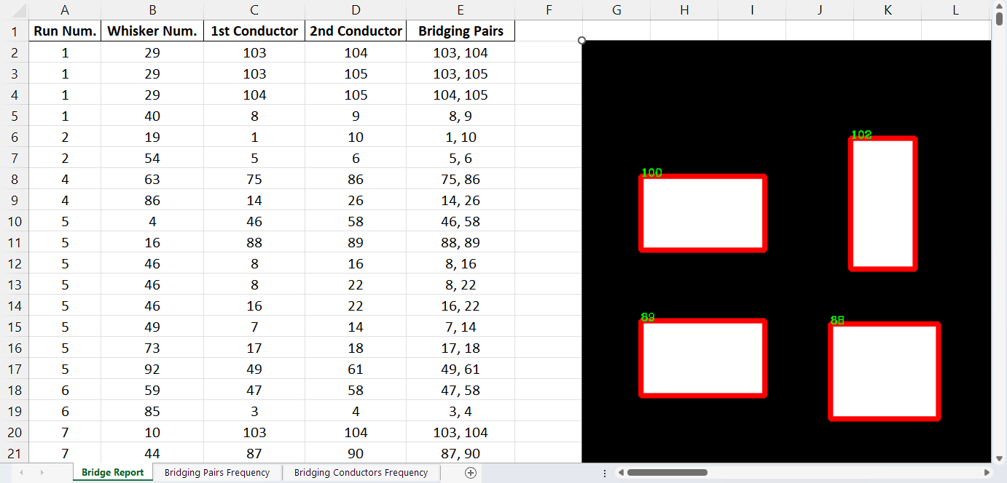

**Figure 14:** Bridge Report

* + - Sheet #2: Bridging conductor pairs, frequency, and corresponding bar chart

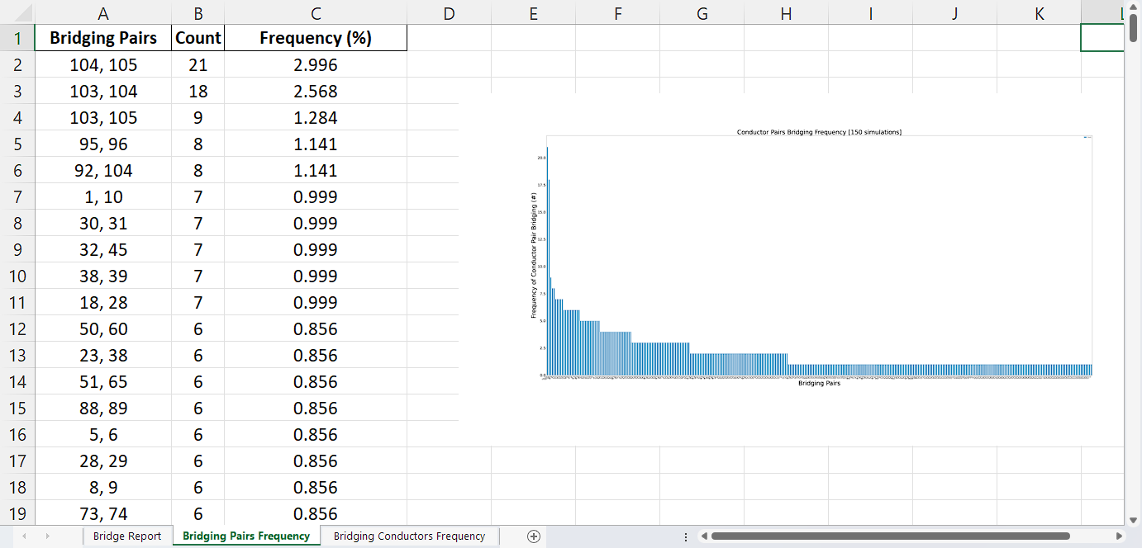

**Figure 15:** Bridging Conductor Pairs Frequency

* + - Sheet #3: Bridging conductor, frequency, and corresponding bar chart

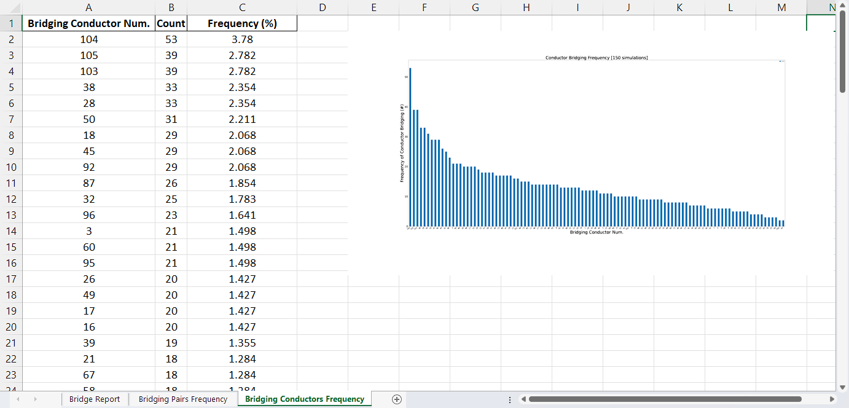

**Figure 16:** Bridging Conductors Frequency

3.2.2 Plots**:** Four plots could be assessed by clicking the corresponding buttons and they could be found at the same directory as the code.

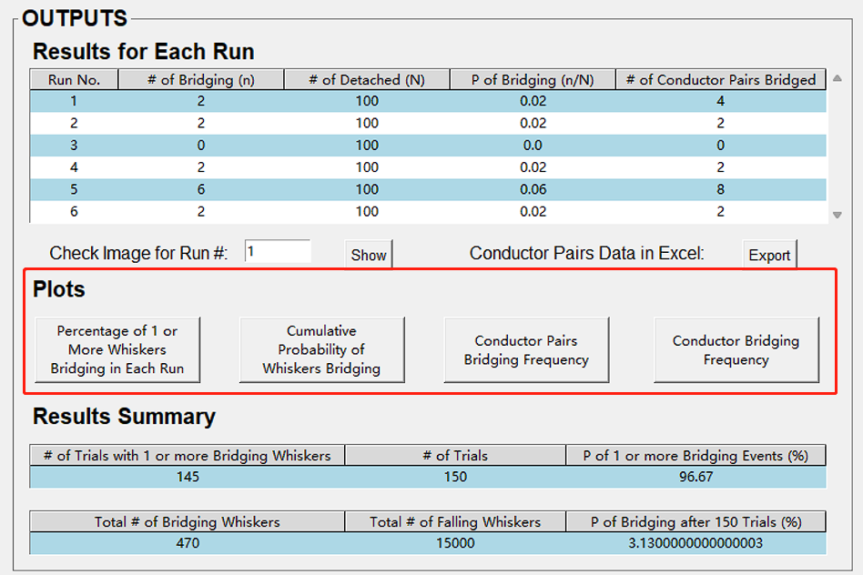

**Figure 17:** Plots Section

1. Percentage of 1 or More Whiskers Bridging in Each Run

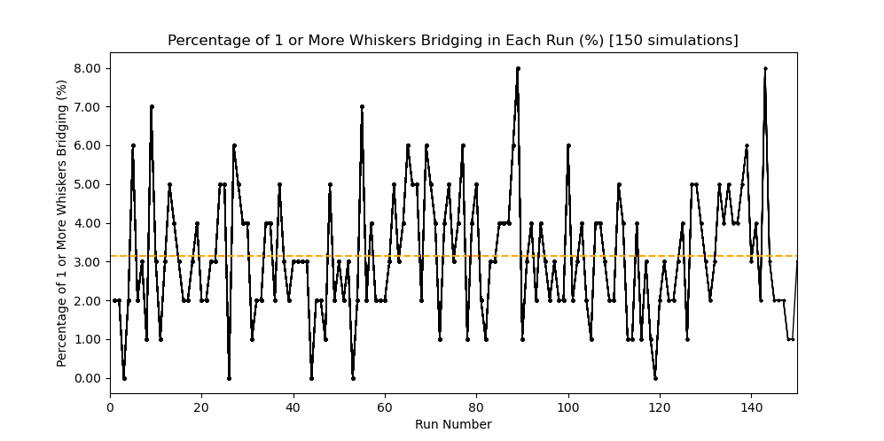

**Figure 18:** Run Number vs. Percentage of 1 or More Whiskers Bridging

1. Cumulative Probability of Whiskers Bridging

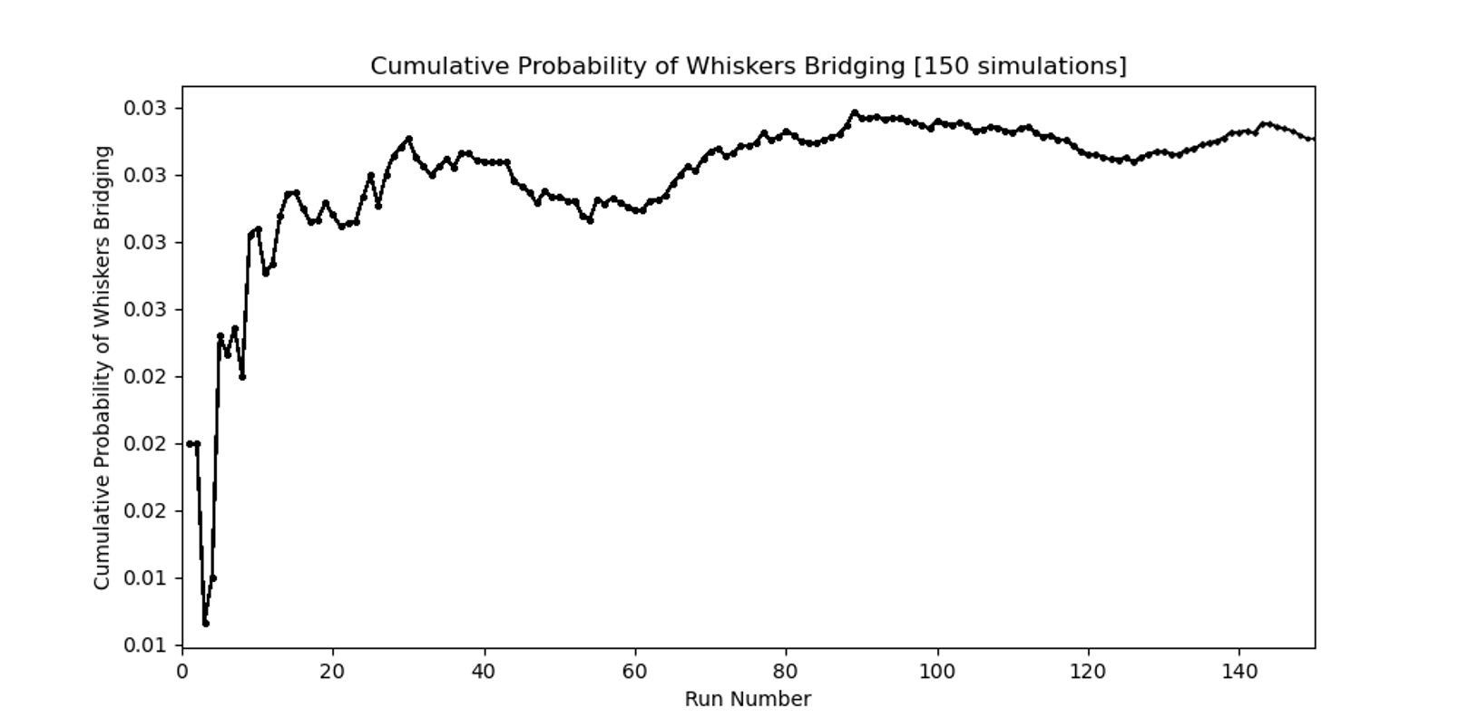

**Figure 19:** Run Number vs. Cumulative Probability of Whiskers Bridging

1. Conductor Pairs Bridging Frequency

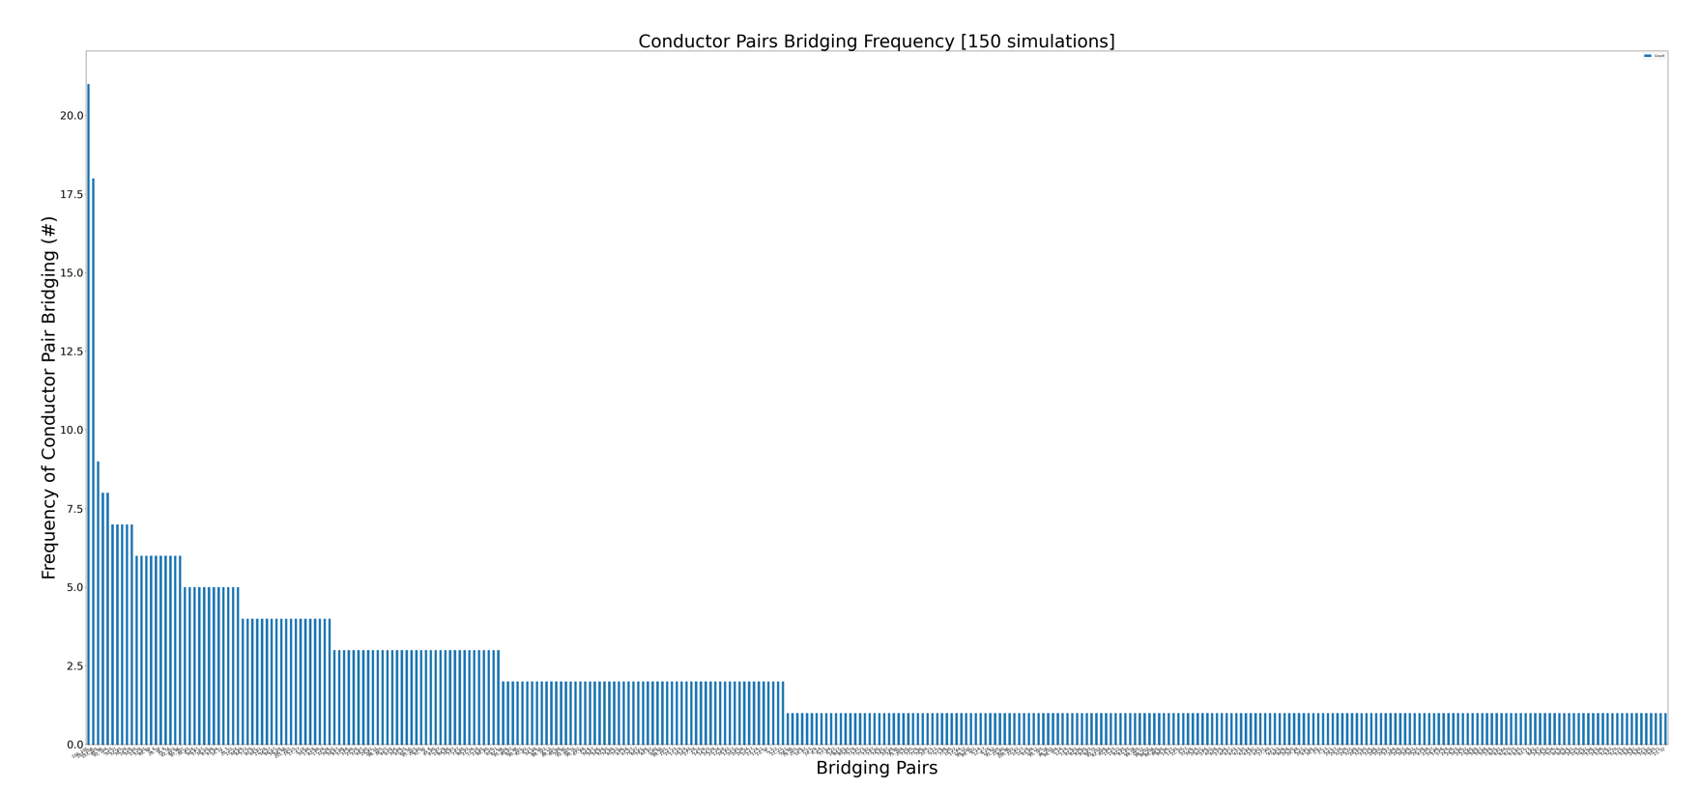

**Figure 20:** Bridging Pairs vs. Frequency of Conductor Pair Bridging

1. Conductor Bridging Frequency

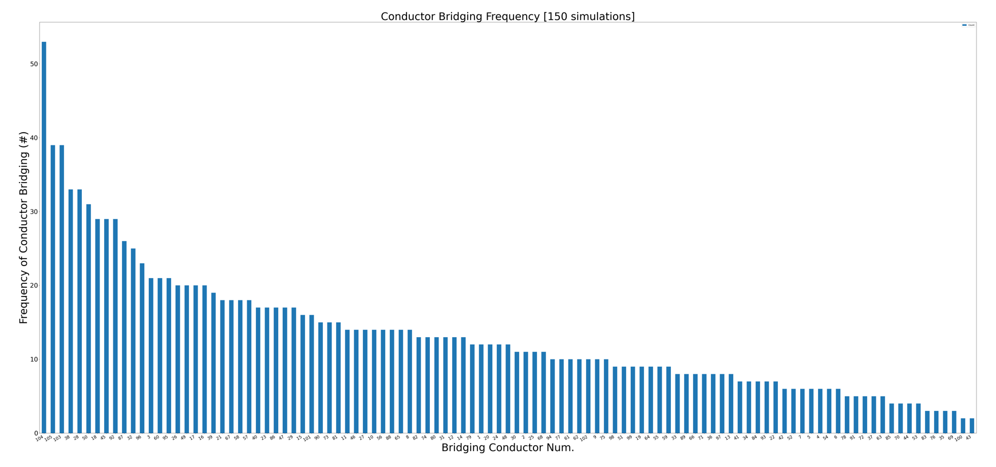

**Figure 21:** Bridging Conductor Numbers vs. Frequency of Conductor Bridging

3.2.3 Results Summary**:** This part shows the number of trials with 1 or more bridging whiskers with number of total trials, total number of bridging whiskers with total number of falling whiskers, and their corresponding probabilities.

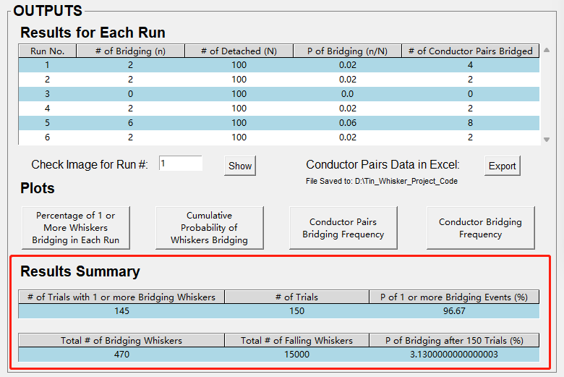

**Figure 22:** Results Summary Section

1. Probability of one or more bridging events. As **Figure 20** shows, 145 trials have at least one whisker that is bridging out of 150 trials. Thus, the **Probability of 1 or more Bridging Events** = 145 / 150 * 100% = 96.67%.
2. Probability of whisker bridging on the circuit board after “N” simulations. This probability was calculated by dividing the number of bridging whiskers by the total number of falling whiskers in all simulations. In this case, **Probability of Bridging after 150 Trials** = 470 / 15000 * 100% = 3.13%.

# 4 – Monte Carlo Simulation Logic

## 4.1 Major Modeling Assumptions

In order to limit the scope and size of the modeling effort, several practical assumptions need to be made. The dominant assumptions are listed below:

1. Whiskers are mechanically robust, linear structures which do not exhibit curvature in two-dimensional space.
2. All whiskers are detached from conductors and randomly falling in the two-dimensional circuit board
3. The shapes of all conductors are transformed into rectangles by the smallest contour able to encompass the conductors.
4. Once a whisker bridges between two conductors, a short circuit occurs. No minimum threshold voltage is used for electrical conduction to take place.
5. No whisker-to-whisker interaction shorting takes place.
6. No detailed growth physics, chemistry, or materials science are explicitly included, because the growth theory has not been fully worked out.



**Figure 23:** Cartoon Shows How Monte Carlo Simulation is Performed on the PWB with 11 Whiskers

## 4.2 Simulation Flowchart

Once the user clicks on the **RUN** button in the GUI, the Monte Carlo simulation in Python code is run as the flowchart shows.

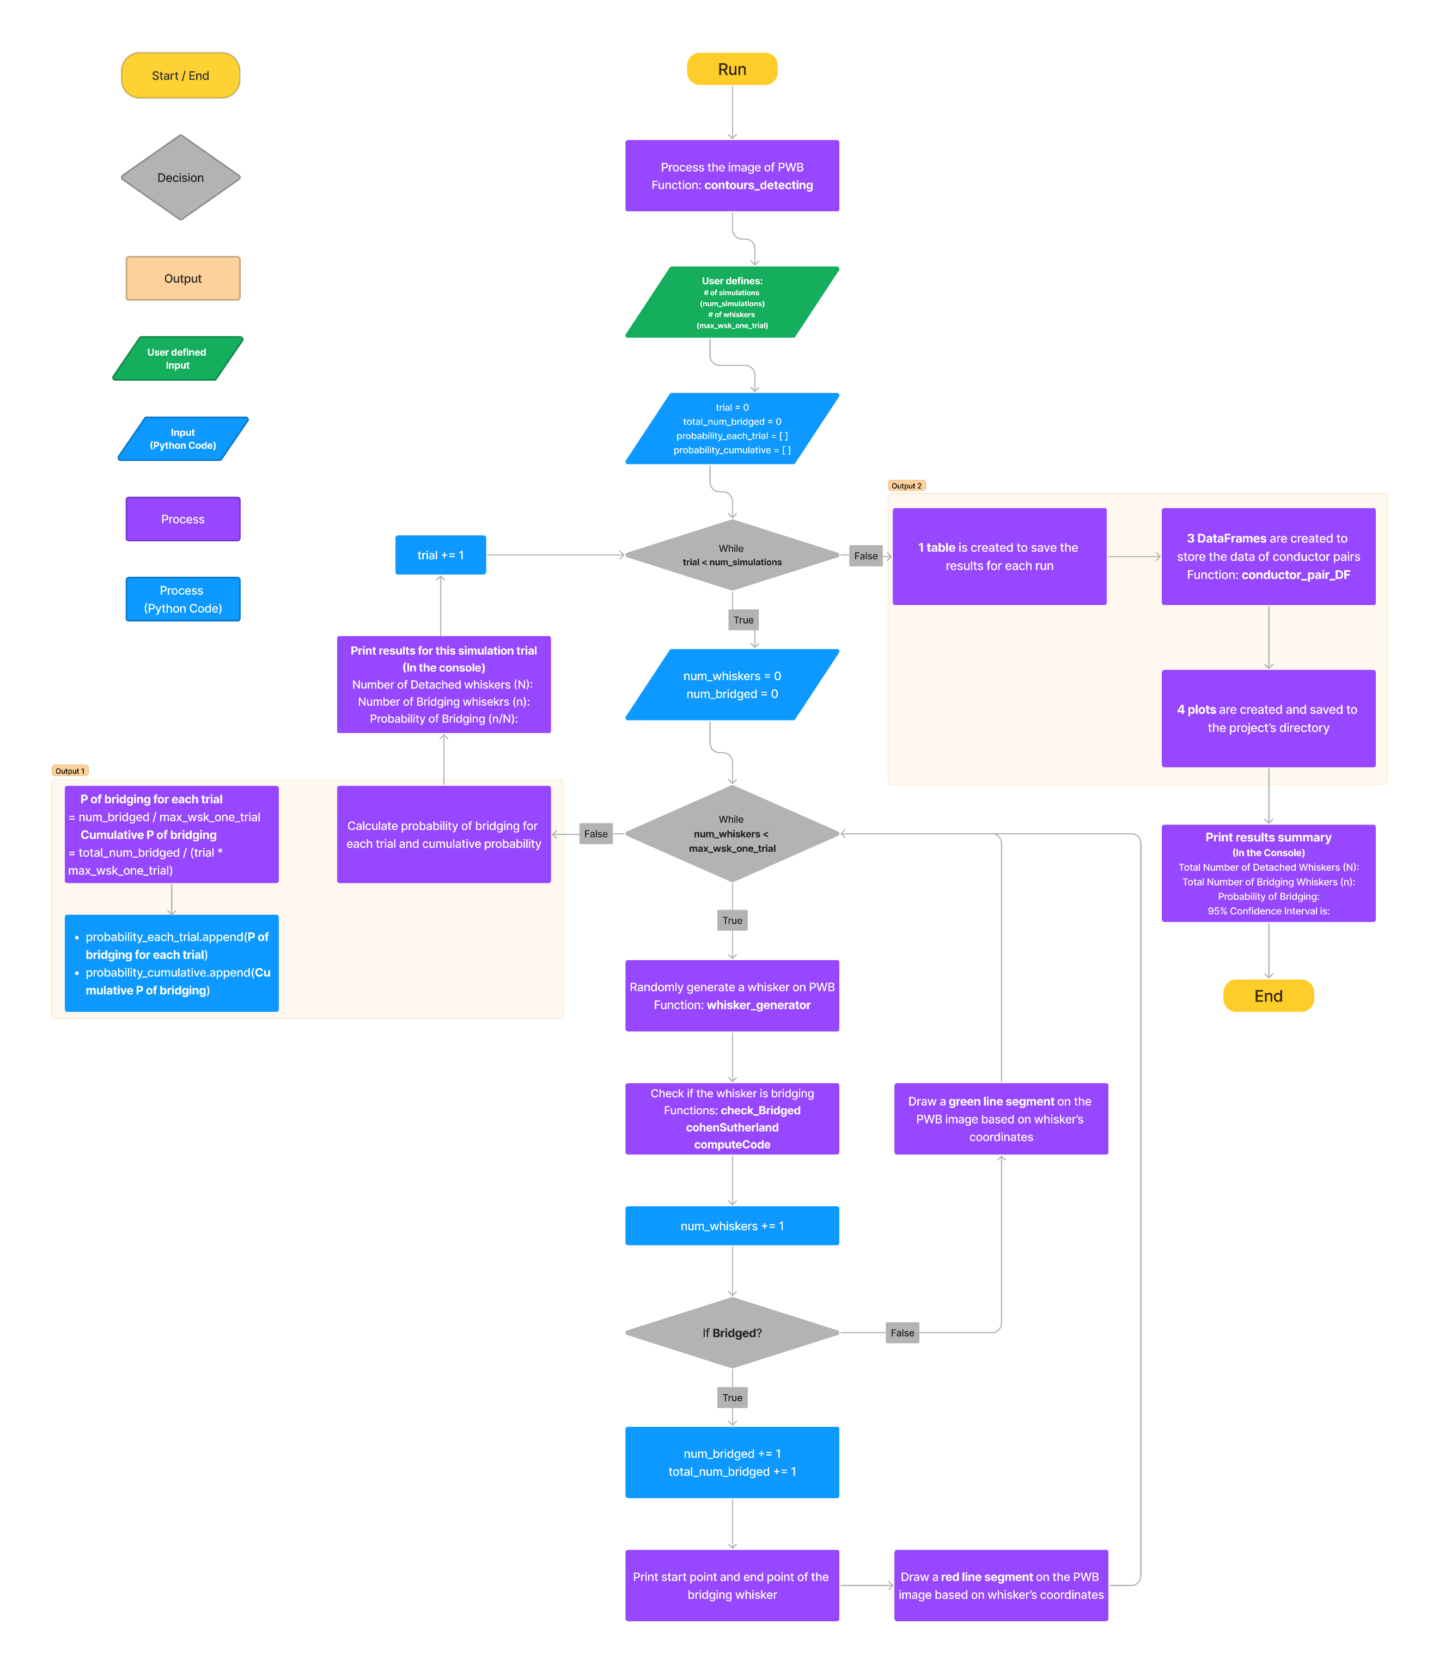

**Figure 24:** Monte Carlo Simulation Code Flowchart

## 4.3 Key Functions Illustration

In “**Main_Monte_Carlo.py**” file:

4.3.1 contours_detecting **(*image_path, PWB_W_True, PWB_L_True*)**

This function is used to process the circuit board image.

1. **Input variables (User-defined):**
   1. *image_path*: the image file path in your computer
   2. *PWB_W_True*: The width of PWB inputted by user in millimeter
   3. *PWB_L_True*: The length (height) of PWB inputted by user in millimeter
2. **Outputs:** 
   1. *File*: “Circuit Board Layout with Conductor Numbers.png” saved to your project directory
   2. *contours*: a list includes a series of lists which stored all coordinates of conductors on the PWB
3. **How this function works:**
   1. Read the file from *image_path*, and get the PWB dimension in pixels
   2. **(Important step)** Resize the ratio of PWB’s length to width in pixels to the same as the ratio of PWB’s length to width in millimeters. The one with the higher value of length or width in pixels remains unchanged. This step ensures that the processed image is to the same scale as the real PWB.
   3. Convert image to a binary image, black and white only image, to increase the image processing accuracy
   4. Detect all conductors, get their coordinates, and store those coordinates to *contours*
   5. Draw a plotting scale at bottom right of the image
   6. Assign a number to each conductor on the PWB
   7. Save the image to project directory

### 4.3.2 whisker_generator ()

This function is used to randomly generate a whisker on the PWB.

1. **Input variables (User-defined):**
   1. *mu_length*: mu of whisker length from lognormal distribution
   2. *sigma_length*: sigma of whisker length from lognormal distribution
   3. *mu_thickness*: mu of whisker thickness from lognormal distribution
   4. *sigma_thickness*: sigma of whisker thickness from lognormal distribution
2. **Outputs:**
   1. *x_start*: the x coordinate of start points of a whisker
   2. *y_start*: the y coordinate of start points of a whisker
   3. *x_end*: the x coordinate of end points of a whisker
   4. *y_end*: the y coordinate of end points of a whisker
   5. *wsk_length*: the length of whisker
   6. *wsk_thickness*: the thickness of whisker
   7. *ratio_avg*: the average of the ratio of the PWB’s length in micron to the one in pixels and the ratio of the PWB’s width in micron to the one in pixels
3. **How this function works:**
   1. Randomly generate a whisker start point within the PWB and an angle
   2. Calculate the average of ratio of length in microns to length in pixels and width in microns to width in pixels, to get 1 pixel = How many microns
   3. **(Important step)** Generate whisker length and thickness based on lognormal distribution (in microns) and divide the length and thickness by the average ratio to get the whisker length and thickness in pixels.
   4. Calculate the coordinate of this whisker’s end point

4.3.3 computeCode **(*x, y, x_min, y_min, x_max, y_max*):**

This function is used to compute the region code for a point (x, y).

1. **Input variables (User-defined):**
   1. *x*: the x coordinate of a whisker’s endpoint
   2. *y*: the y coordinate of a whisker’s endpoint
   3. *x_min*: the x coordinate of top left corner point of a rectangular conductor
   4. *y_min*: the y coordinate of top left corner point of a rectangular conductor
   5. *x_max*: the x coordinate of bottom right corner point of a rectangular conductor
   6. *y_max*: the y coordinate of bottom right corner point of a rectangular conductor
2. **Output:**
   1. *code*: a region code represents where the point lies relative to the rectangular conductor
      * *code = 0000* if the point is INSIDE the rectangle
      * *code = 0001* if the point is outside the LEFT boundary of the rectangle
      * *code = 0010* if the point is outside the RIGHT boundary of the rectangle
      * *code = 0100* if the point is outside the BOTTOM boundary the rectangle
      * *code = 1000* if the point is outside the TOP boundary the rectangle
3. **How this function works:**
   1. Initially *code* = INSIDE
   2. Determine if the x of the point is less than *x_min­* or larger than *x_max*.
      * If less, *code =* LEFT; otherwise, *code* = RIGHT
   3. Determine if the y of the point is less than *y_min­* or larger than *y_max.*
      * If less, *code =* BOTTOM; otherwise, *code* = TOP

4.3.4 cohenSutherland **(*x1, y1, x2, y2, m, c, x_min, y_min, x_max, y_max, bridged_rec, rec_num*)**

This function is used to determine the relationships between a whisker and a conductor on the PWB.

1. **Input variables:**
   1. *x1*: the x coordinate of start points of a whisker
   2. *y1*: the y coordinate of start points of a whisker
   3. *x2*: the x coordinate of end points of a whisker
   4. *y2*: the y coordinate of end points of a whisker
   5. *m*: the slope of a whisker line segment
   6. *c*: the y-intercept of the whisker line segment
   7. *x_min*: the x coordinate of top left corner point of a rectangular conductor
   8. *y_min*: the y coordinate of top left corner point of a rectangular conductor
   9. *x_max*: the x coordinate of bottom right corner point of a rectangular conductor
   10. *y_max*: the y coordinate of bottom right corner point of a rectangular conductor
   11. *rec_num*: an integer represents the rectangle’s number. The rectangle corresponding to this number is being detected by the algorithm to see if a whisker intersects with it.
   12. *bridged_rec*: a list to store all bridging rectangles’ number in a run (**empty list** at the beginning of each run)
2. **Outputs:**
   1. *rectangle_status*: a number represents every rectangle’s status in a run
   2. *bridged_rec*: a list to store all bridging rectangles’ number in a run
3. **How this function works:**
   1. Use **computeCode ()**function to compute the region codes of the two endpoints of a whisker
   2. Use these two region codes to determine the relationship (*rectangle_status*) between a whisker and all conductors
   3. If both endpoints of the whisker line segment lie within a rectangle, *rectangle_status* = 1
   4. If both endpoints of the whisker line segment lie outside a rectangle and the whisker doesn’t cross over the rectangle, *rectangle_status* = 0
   5. If the whisker line segment crosses over one or two boundaries of a rectangle, *rectangle_status* = 0.5. Add this rectangle number to *bridged_rec* list.

### 4.3.5 check_Bridged ()

This function is used to determine if a whisker is bridging two or more conductors.

1. **Input variable**:
   1. *Rectangle_list*: a global list to include all rectangles’ coordinates
2. **Outputs:**
   1. *bridged*: a Boolean value return **True** if a whisker is bridging two or more conductors, while return **False** if not bridging.
   2. *x_s*: the x coordinate of start points of a whisker
   3. *y_s*: the y coordinate of start points of a whisker
   4. *x_e*: the x coordinate of end points of a whisker
   5. *y_e*: the y coordinate of end points of a whisker
   6. *rec_status*: a list storing every whisker’s status in a run
   7. *wsk_length*: the length of the whisker
   8. *wsk_thickness*: the thickness of the whisker
   9. *bridged_rectangle*: a list to store all bridging rectangles’ number in a run
   10. *ratio_avg*: the average of the ratio of the PWB’s length in micron to the one in pixels and the ratio of the PWB’s width in micron to the one in pixels
3. **How this function works:**
   1. Use **whisker_generator ()** function to randomly generate a whisker
   2. Calculate the equation of the whisker line segment
   3. Loop over every rectangle in *Rectangle_list*
      * For each rectangle, use **cohenSutherland ()** function to determine if a whisker is crossing over the rectangle
      * Add *rectangle_status* from this function to the *rec_status* list
   4. If there are more than one ***rectangle_status* = 0.5** in *rec_status* list, then *bridged* = **True**; otherwise, *bridged* = **False**

4.3.6 calculate_resistance **(*wsk_length, wsk_thickness, ratio_avg*)**

This function is used to calculate resistance of a whisker.

1. **Input variables:**
   1. *wsk_length*: the length of the whisker
   2. *wsk_thickness*: the thickness of the whisker
   3. *ratio_avg*: the average of the ratio of the PWB’s length in micron to the one in pixels and the ratio of the PWB’s width in micron to the one in pixels
2. **Output:**
   1. *resistance*: the resistance of the whisker
3. **How this function works:**
   1. Define the resistivity of Tin in microns, 0.11 Ohm micron
   2. Convert the resistivity of Tin in micron to the one in pixels
      * Divide the resistivity of Tin in microns by *ratio_avg*
   3. Calculate the cross-section area of the tin whisker
      * A = pi\**wsk_thickness*^2 / 4
   4. Calculate the resistance
      * *resistance* = resistivity in pixels * *wsk_length* / A

### 4.3.7 conductor_pair_DF ()

This function is used to store the conductor pairs data and results as DataFrames.

1. **Input variables:**
   1. *brg_rec_data*: a global list to store all bridging rectangles’ number in all runs
   2. *wsk_num_data*: a global list to store all bridging whiskers’ number in all runs
2. **Outputs:**
   1. *df1*: DataFrame includes columns of “Run Num.”, “Whisker Num.”, “1st Conductor”, “2nd Conductor”, and “Bridging Pairs” and corresponding data
   2. *df2*: DataFrame includes columns of “Bridging Pairs”, “Count”, and “Frequency (%)” and corresponding data
   3. *df3*: DataFrame includes columns of “Bridging Conductor Num.”, “Count” and “Frequency (%)” and corresponding data
3. **How this function works:**
   1. Get each column data from *brg_rec_data* and *wsk_num_data* by looping over all simulation runs
   2. Create 3 DataFrames *df1, df2,* and *df3* to organize the conductor pairs data

4.3.8 draw_img **(*imageNum*)**

This function is used to display the corresponding image according to the number entered by the user.

1. **Input variables:**
   1. *imageNum*: the number that user input to the “Check Image for Run #” box
   2. *PWB_W_pixel*: A global variable represents the width of PWB in pixels
   3. *PWB_L_pixel*: A global variable represents the length (height) of PWB in pixels
   4. *PWB_W_True*: A global variable represents the width of PWB inputted by user in millimeter
   5. *PWB_L_True*: A global variable represents the length (height) of PWB inputted by user in millimeter
   6. *Rectangle_list*: a global list to include all rectangles’ coordinates
   7. *Wsk_points_data*: a global list to include all whiskers’ endpoints data and their bridging status in color (red = bridge; green = not bridge)
2. **Outputs:**
   1. Display the image
3. **How this function works:**
   1. Draw the PWB in black using *PWB_W_pixel* and *PWB_L_pixel*
   2. Calculate the *ratio_avg*, which is used to scale the plotting scale, thickness of line, and size of the conductors’ number
   3. Draw all conductors in white on the PWB and corresponding conductor numbers in orange
   4. Draw the whiskers in either red or green on the PWB
   5. Draw the plotting scale with the text label
   6. Display the image

### 4.3.9 export_Pairs_Data ()

This function is used to save the data of conductor pairs to Excel.

1. **Input variables:**
   1. *DF1*: a global DataFrame obtained from the *df1 in* **conductor_pair_DF ()** function
   2. *DF2*: a global DataFrame obtained from the *df2 in* **conductor_pair_DF ()** function
   3. *DF3*: a global DataFrame obtained from the *df3 in* **conductor_pair_DF ()** function
2. **Outputs:**
   1. An Excel file with three sheets
   2. *No_Bridging_Whisker*: a Boolean variable returns **True** if there is no bridging whisker in all simulations; **False** if there is at least one bridging whisker in all simulations
3. **How this function works:**
   1. Create an Excel file named “Output after {} runs ({} whiskers in each run).xlsx” ({} is obtained from the input of the user) and save to the project’s directory
   2. Create three sheets, “Bridge Report”, “Bridging Pairs Frequency”, “Bridging Conductors Frequency” to this Excel file
   3. Check if *DF1* is empty. Empty *DF1* means there is not bridging events occurring in all simulations.
      * *No_Bridging_Whisker* = **True** if *DF1* is empty
      * *No_Bridging_Whisker* = **False** if *DF1* is not empty
   4. If DF1 is not empty, add columns’ data from *DF1, DF2,* and *DF3* to corresponding sheet
   5. Insert “Circuit Board Layout with conductor numbers.png” to sheet “Bridge Report”
   6. Insert “Conductor Pairs Bridging Frequency after {} simulations.png” to sheet “Bridging Pairs Frequency”
   7. Insert “Conductor Bridging Frequency after {} simulations.png” to sheet “Bridging Conductors Frequency”
   8. Save the Excel file

# 5 - Codes for GUI and Monte Carlo Simulation

## 5.1 MCS_gui.py

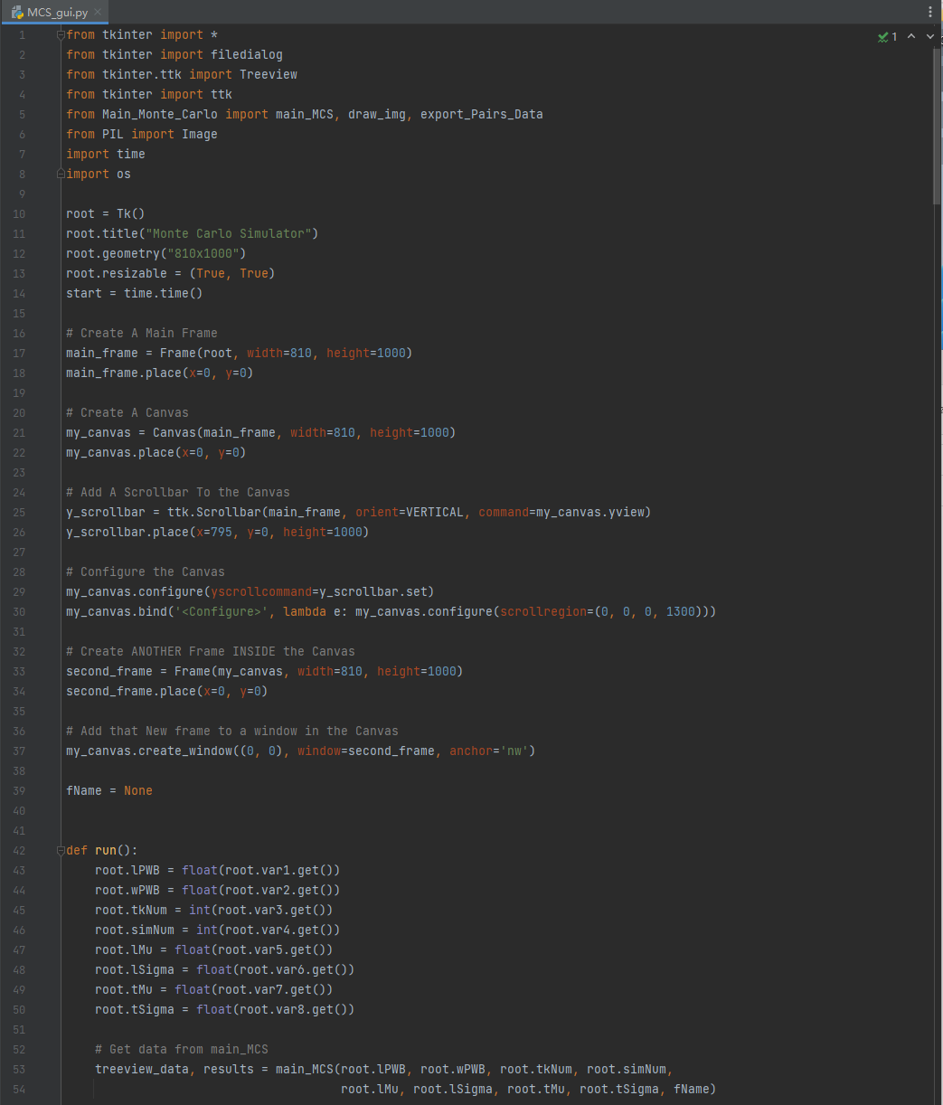

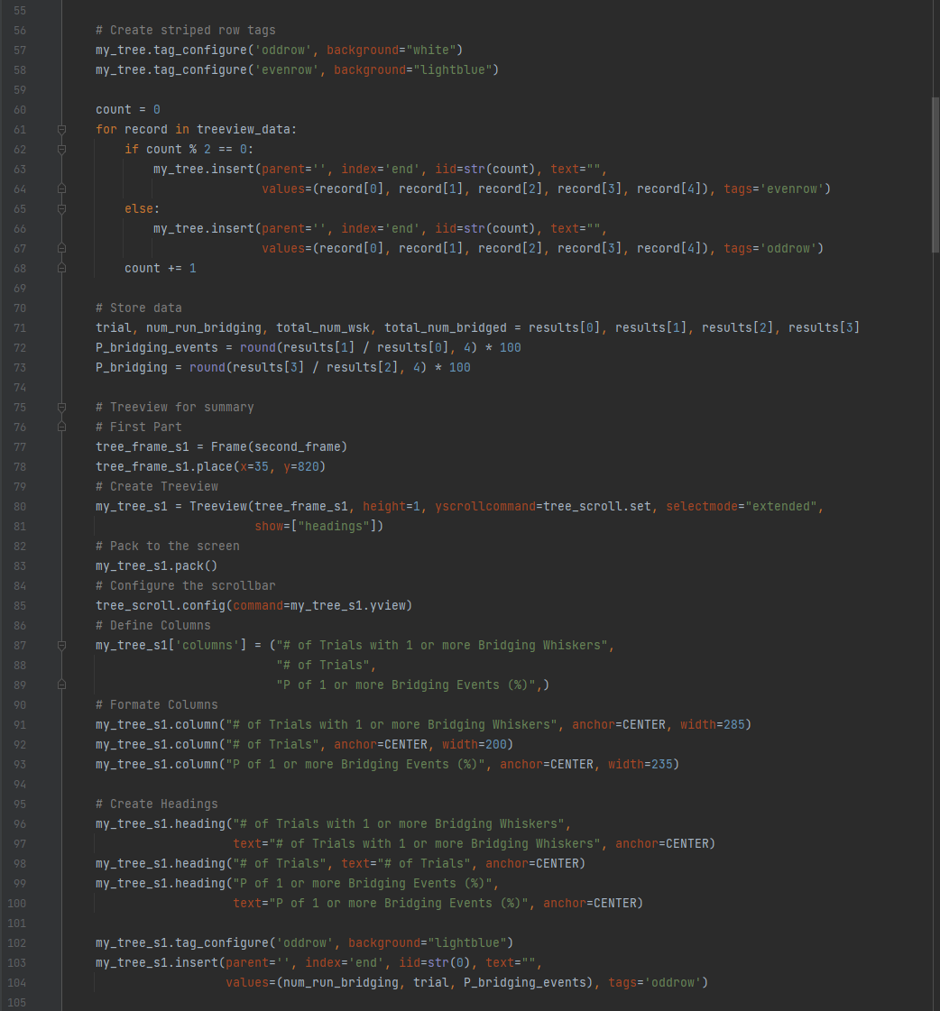

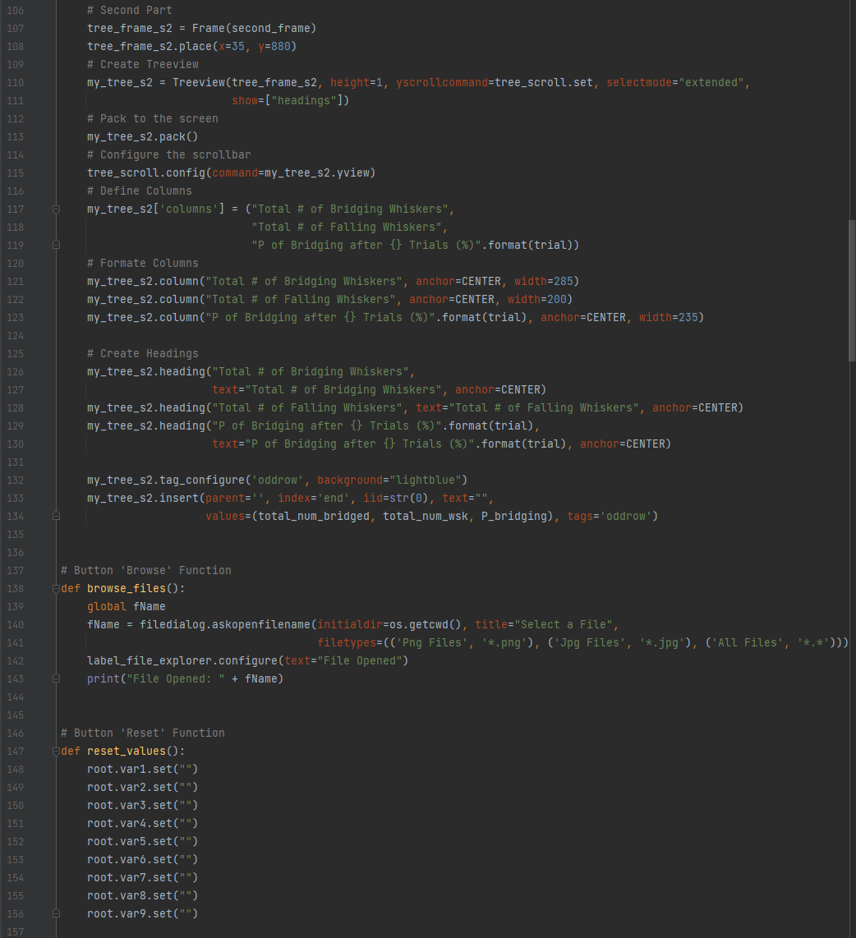

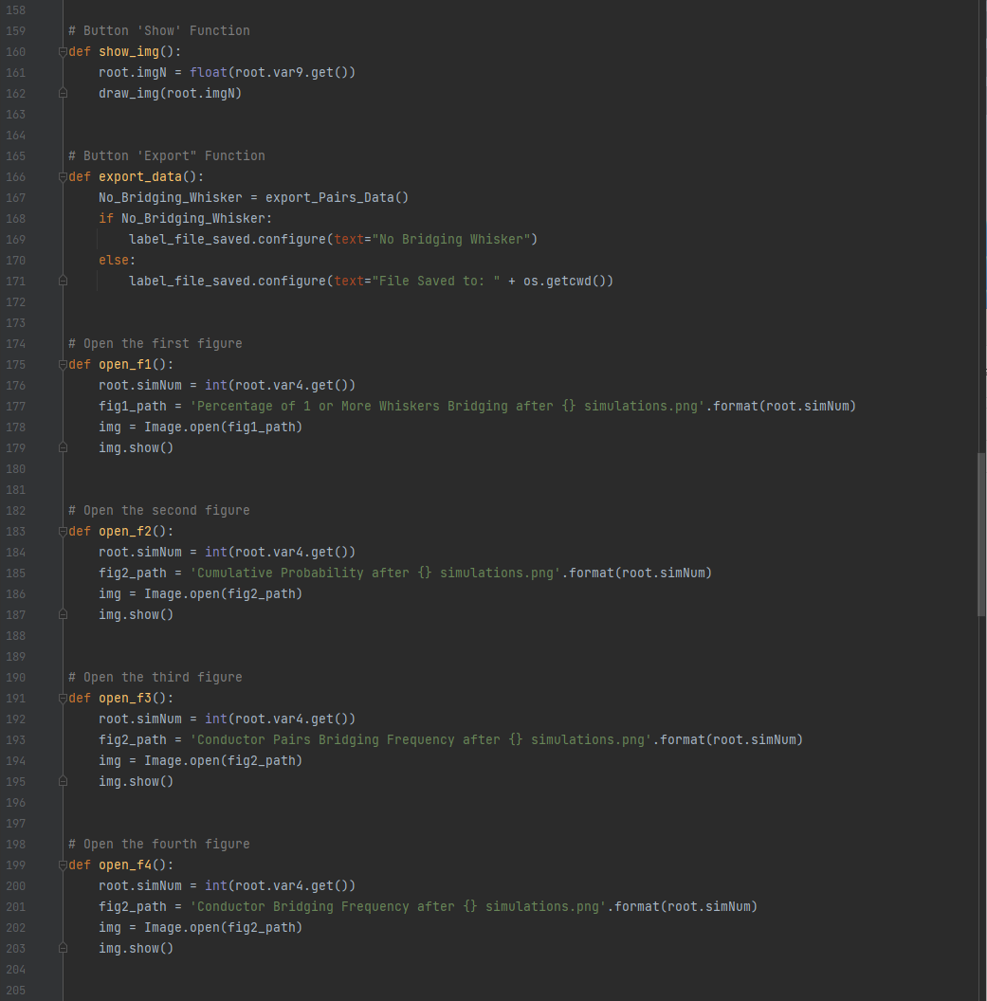

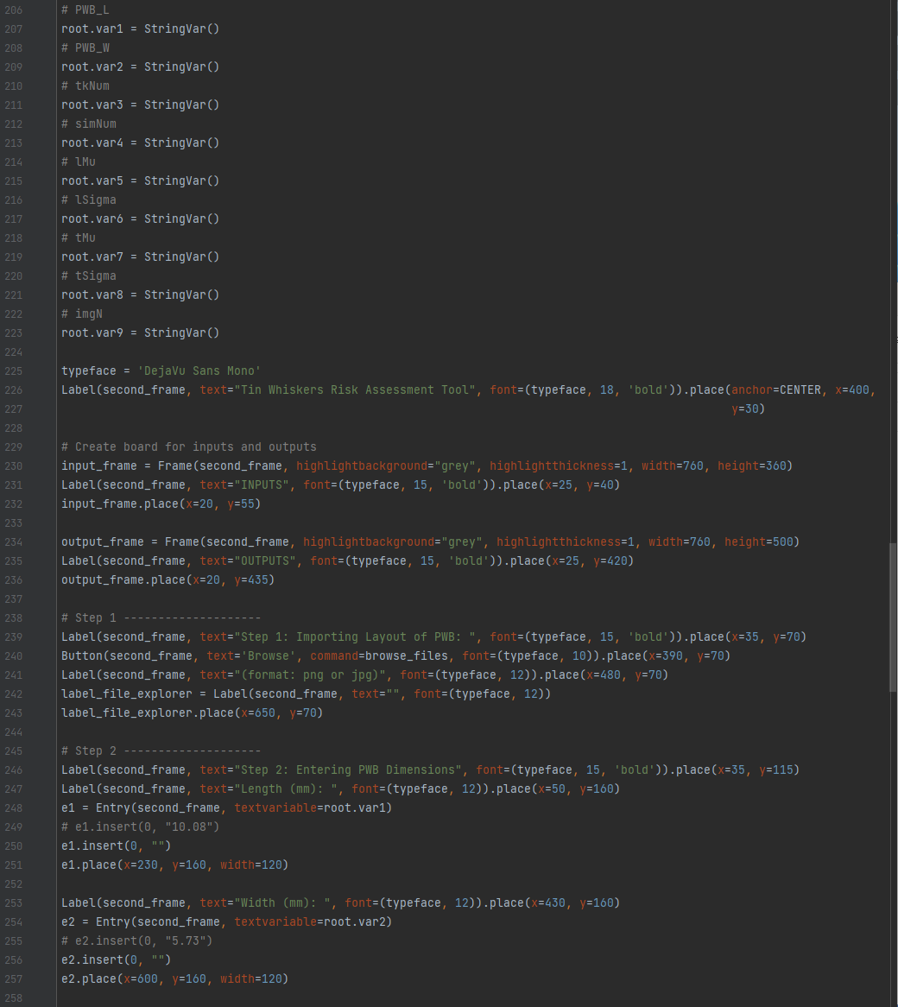

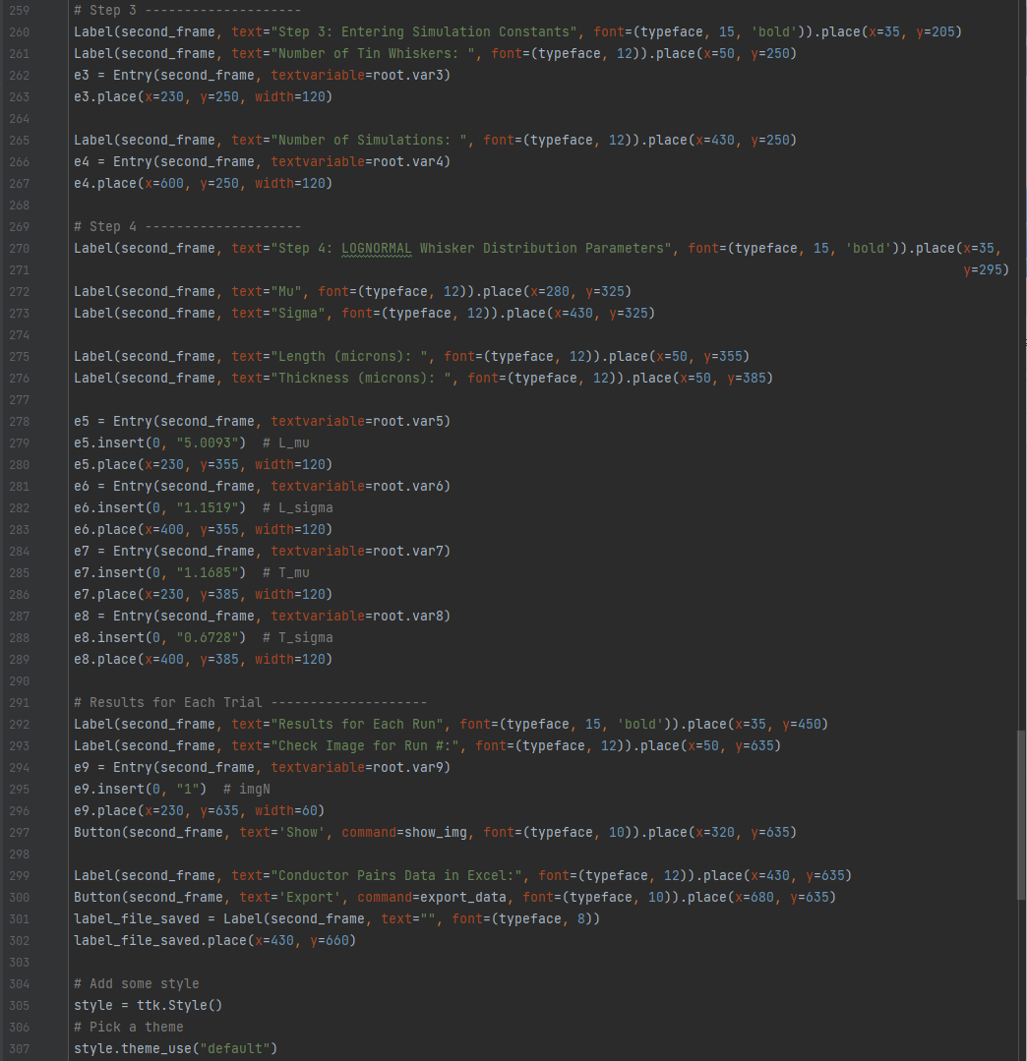

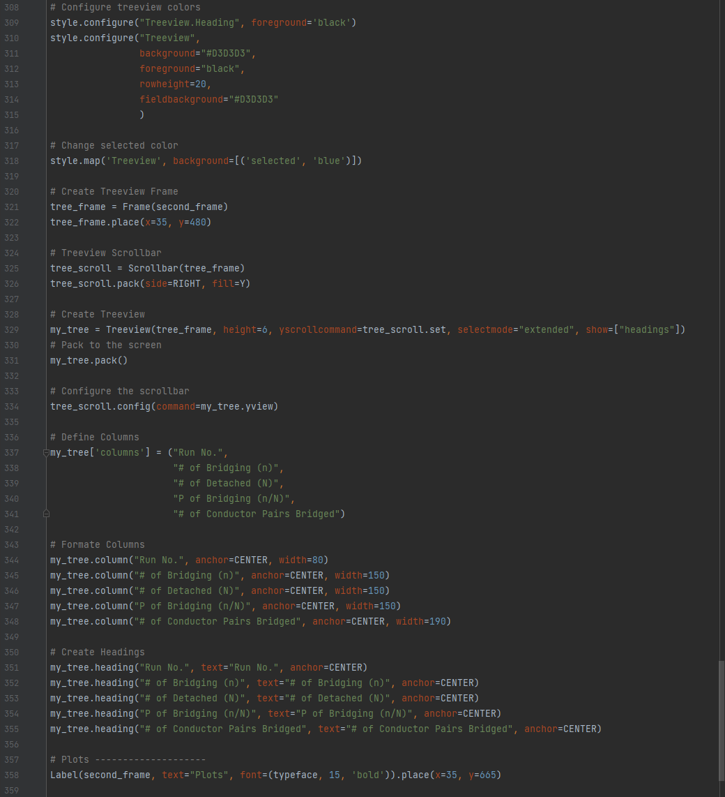

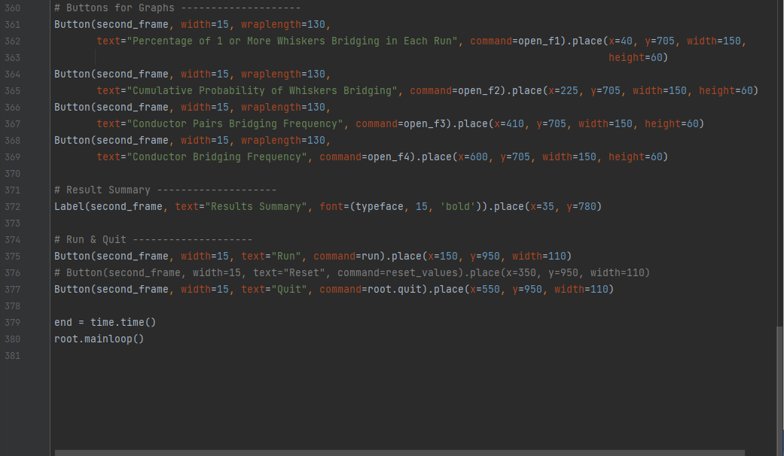

## 5.2 Main_Monte_Carlo.py

